Project Planning Phase
Project Planning Template (Product Backlog, Sprint Planning, Stories, Story Points)
Date | 6th September 2026
Team ID | SWUID2026190363
Project Name | Metro Ticket Generating System in ServiceNow
Maximum Marks | 5 Marks

Product Backlog, Sprint Schedule, and Estimation (4 Marks)
The product backlog below is based on the Metro Ticket Generating System scope: station data, ticket booking, fare calculation, QR generation, payment selection, portal UI, testing and deployment.
Sprint | Functional  Requirement (Epic) | User Story  Number | User Story / Task | Story  Points | Priority | Team  Members
Sprint-1 | Station & Ticket Setup | USN-1 | As an admin, I can create and maintain metro station details so that passengers can select valid stations. | 3 | High | Project Team
Sprint-1 | Station & Ticket Setup | USN-2 | As a passenger, I can select Starting From and Going To stations from the station list. | 2 | High | Project Team
Sprint-1 | Ticket Booking | USN-3 | As a passenger, I can book a metro ticket by selecting journey type and number of passengers. | 3 | High | Project Team
Sprint-2 | Fare Calculation | USN-4 | As a passenger, I can view the fare for a single journey based on my booking details. | 3 | High | Project Team
Sprint-2 | Fare Calculation | USN-5 | As a passenger, I can view the fare for a return journey and multiple passengers. | 3 | High | Project Team
Sprint-2 | Payment Selection | USN-6 | As a passenger, I can select a payment mode such as UPI, Card or Others. | 2 | Medium | Project Team
Sprint-3 | QR Ticket | USN-7 | As a passenger, I can receive a QR-based digital ticket after submitting the booking. | 3 | High | Project Team
Sprint-3 | QR Ticket | USN-8 | As a passenger, I can view the generated QR ticket in the ServiceNow portal widget. | 2 | High | Project Team
Sprint-4 | Security & Testing | USN-9 | As an administrator, I can use table access controls for the metro station data. | 2 | Medium | Project Team
Sprint-4 | Security & Testing | USN-10 | As a project team, I can test the complete booking-to-QR flow and prepare the solution for deployment. | 3 | High | Project Team

Project Tracker, Velocity & Burndown Chart (4 Marks)
Sprint | Total Story  Points | Duration | Sprint Start Date | Sprint End Date  (Planned) | Story Points Completed (as on Planned End Date) | Sprint Release Date  (Actual)
Sprint-1 | 8 | 6 Days | 07 Sep 2026 | 12 Sep 2026 | — | —
Sprint-2 | 8 | 6 Days | 14 Sep 2026 | 19 Sep 2026 | — | —
Sprint-3 | 5 | 6 Days | 21 Sep 2026 | 26 Sep 2026 | — | —
Sprint-4 | 5 | 6 Days | 28 Sep 2026 | 03 Oct 2026 | — | —

Velocity:
Total planned story points = 26. With a 6-day sprint duration, the planned average work rate is approximately 26 / 24 = 1.08 story points per day across the four sprints. Sprint velocity is planned as 8, 8, 5 and 5 story points respectively.
Burndown Chart:
A burndown chart represents the work remaining against time. The chart below shows the planned remaining story points for the four sprints. Actual completion values can be entered after each sprint is completed.
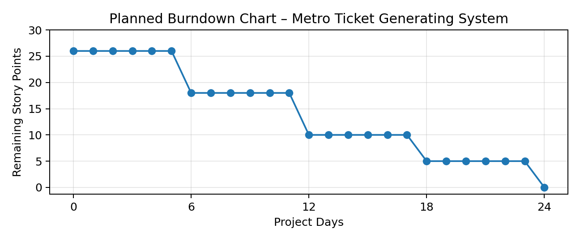
References
https://www.atlassian.com/agile/project-management
https://www.atlassian.com/agile/tutorials/how-to-do-scrum-with-jira-software
https://www.atlassian.com/agile/tutorials/epics
https://www.atlassian.com/agile/tutorials/sprints
https://www.atlassian.com/agile/project-management/estimation
https://www.atlassian.com/agile/tutorials/burndown-charts

